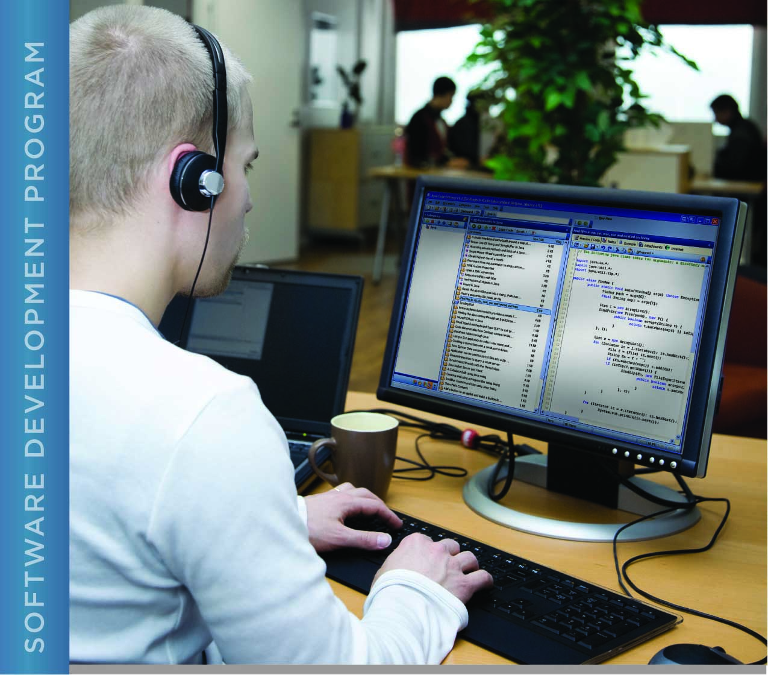

# PERFORMANCE, DATA STRUCTURES AND ALGORITHMS

Exercise 02

Exercise INSTRUCTIONS

UNIX COMMANDS AND HELLO WORLD

# Name: Minakov Nikita CSSE 1709r

PURPOSE

The purpose of this assignment is to give you concrete practice using the course’s LMS website, and to provide you step-by-step guidance on how to download, rename, modify, test, upload, and submit a ‘C’ program exercise. Note: For this exercise, and the ‘C’ programming projects in this course, your Unix environment requires a GCC compiler. Some platforms, such as Mac OSX, do not provide the GCC compiler by default. Most platforms have a compiler available for download. Check your Unix platform documentation if you need to download a GCC compiler and discuss with your instructor.

ACTIVITIES

1. Download the HelloWorld program baseline from the LMS and put it in your development workspace:
   1. Create an exercise02 folder in the “exercises” folder you create during Exercise 01.
   2. Start up your favorite Internet browser.
   3. Log into the LMS using your StudentID and password.
   4. Navigate to the main page for this course and click on the link to display the main page for the course.
   5. Click the Project 01 link to expand the folder. You should see links to project materials and assessments.
   6. Click the 'Project 01 Materials' link associated with the first project and you will see the main page for that project.
   7. Click the exercise .zip file and save it to the exercise02 folder that you created. This file will typically contain the exercise code related to the exercise and will have a title appropriate to the exercise and/or project. In this case the .zip file contains the source code for the HelloWorld program.
   8. Unzip the file to extract the contents into your exercise02 directory.
2. Modify the C source code file, changing the course author’s name to your name in the “printf” command, and verify the program still works.
   1. Navigate to the directory containing the source file “exercise02.c” (in the “src” subdirectory of the “exercise02” directory) using the “cd” command. Open the file in a text editor that you and your instructor have agreed upon.
   2. Find the block comment at the beginning of the program and type your name as the author.
   3. Find the “printf” command that prints out the name of the course author and change it to your name. Be careful to leave the opening and closing quotation marks around the name.
   4. Save the file and compile the program using the gcc command (the compiler): “gcc -Wall exercise02.c”. The -Wall argument tells the compiler to print all warnings. The default name of the compiled program is a.out. You can change this by compiling with the -o option: “gcc -Wall exercise02.c -o ex2” will name the compiled program “ex2”.
   5. Once the program compiles cleanly (with no warnings or errors), run the program: “./a.out”. (The “./” at the beginning of the program name is a path. The dot (“.”) specifies the current directory.)
   6. The program should run and print “Hello World.” on one line, followed by “written by: <your name>” on the next line. If this does not happen, correct the program and perform steps “d” and “e” again.
3. Submit your work to the LMS.
4. Navigate to the directory containing your src directory.
5. Remove the executable file created by the compiler using the “rm” command: “rm name”, where name is the name of the compiled version of your program (e.g. a.out). Be very careful *not* to remove your source file!
6. If you are using a virtual machine, copy the src directory containing your program to your exercise02 folder on the host machine.
7. Compress your exercise02 folder into a zip archive file. To do this:
   * If you are using Windows or a Mac, right click your exercise02 folder and select 'Compress File' (Mac) or 'Izarc->Add to Archive File' (Windows). Be sure to rename the resulting archive file “YourStudentID_exercise02”.
   * If you are using Unix, navigate to the exercises directory and use the zip command to create your archive file: “zip -r YourStudentID_exercise02.zip exercise02”. This creates an archive of your exercise02 directory and names the archive using your student ID.
8. Upload your archive file to the LMS. To do this:
   * Log into the LMS (if you aren't already) using your StudentID and password.
   * Navigate to the main page for your course and click the 'exercise02’ Drop Box link.
   * Click the 'Upload a file' button. Note that the button may say 'Upload files' instead.
   * Click the 'Choose a file' button
   * Click the ‘Upload a file' link
   * Click the 'Browse' button and navigate to the folder where your archived file is located
   * Once the path to the archived file is in the Attachment: text box make sure that your name is listed correctly, and then click the 'Upload this file' button
   * When the LMS has finished uploading your file, you should see the name of the uploaded file. If you don't see this, then you haven't uploaded your file correctly and you need to go back and upload it again. If you do see your file listed in the area then click the 'Update this file' button.
9. To verify that the submission of your deliverable has been successful, navigate to the main page for your course and click the 'exercise02’ link. In the upper right hand corner of the screen, click the 'View 1 submitted assignments' link.
10. Congratulations!

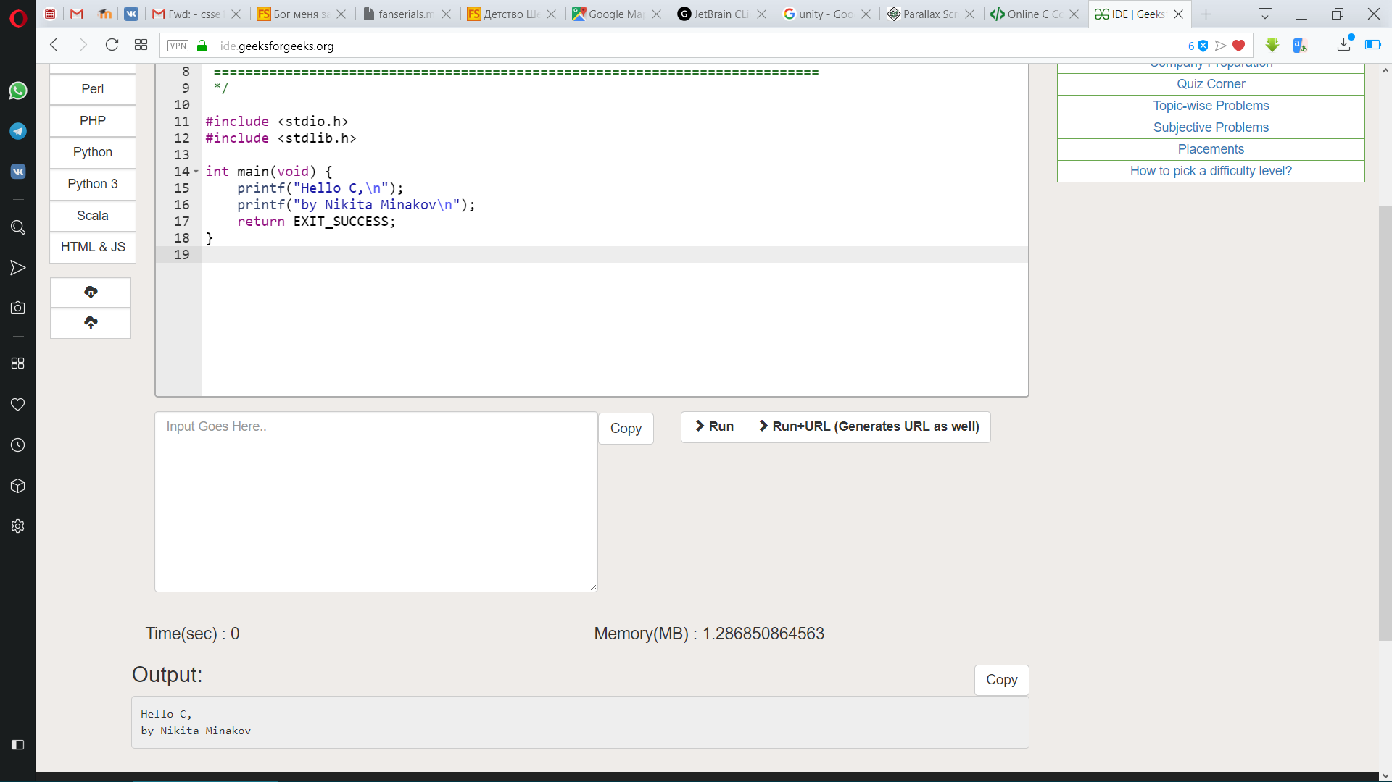

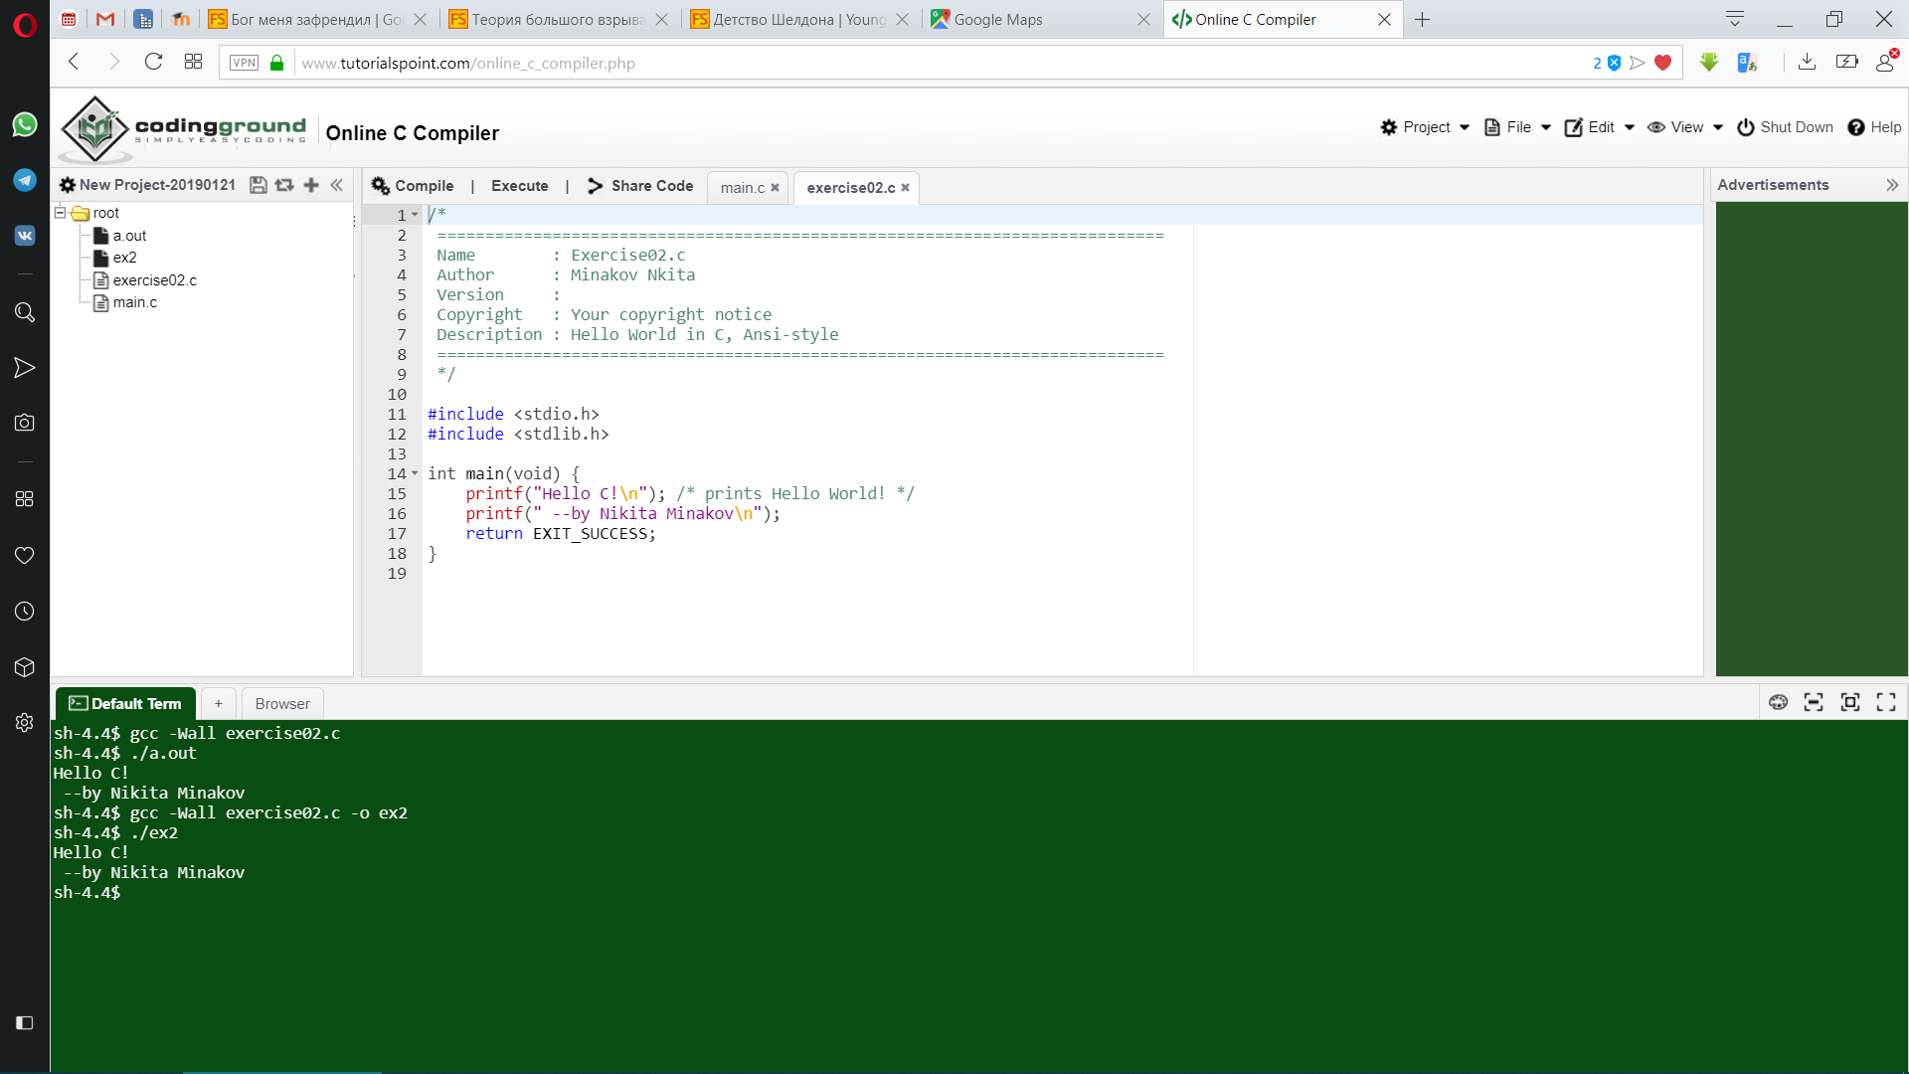

/*

============================================================================

Name : Exercise02.c

Author : Minakov Nikita

Version :

Copyright : Your copyright notice

Description : Hello World in C, Ansi-style

============================================================================

*/

#include <stdio.h>

#include <stdlib.h>

int main(void) {

printf("Hello C,\n");

printf("by Nikita Minakov\n");

return EXIT_SUCCESS;

}